Salesforce Administrator Self-Learning & Super Badges

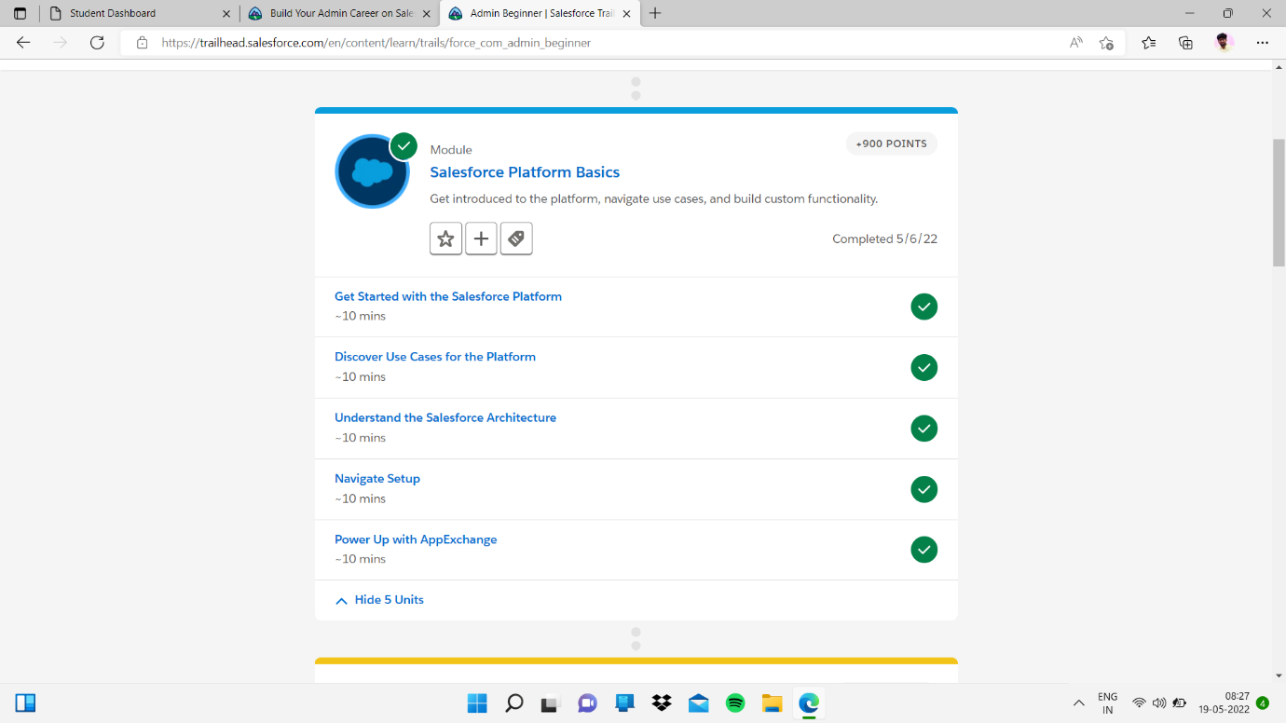

Sub Heading :-

salesforce Fundamentals and user set up

sub Topic :-

Get Started with the Salesforce Platform

My task:-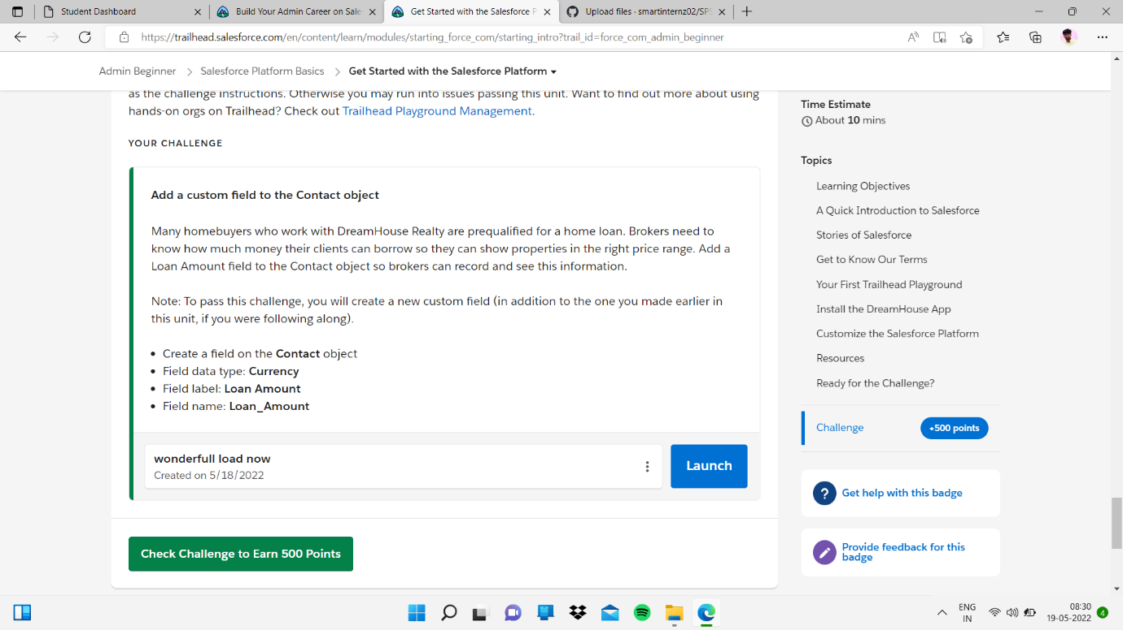

* I clicked Launch button then

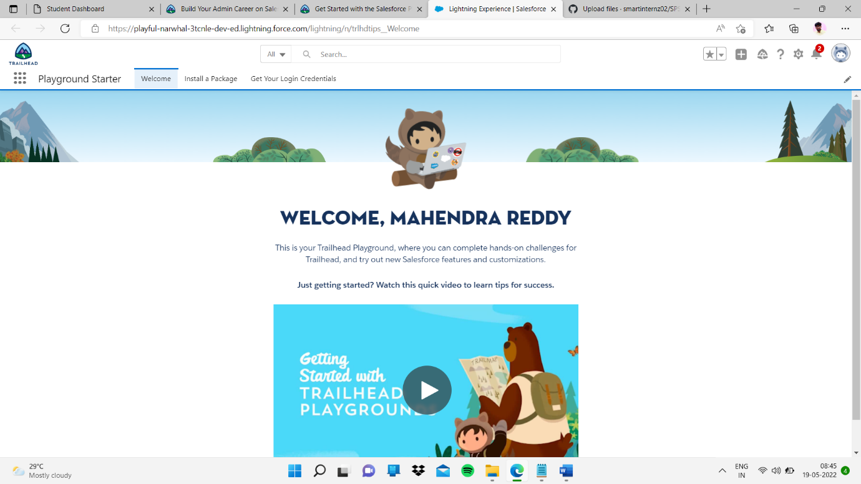

And I clicked setup then

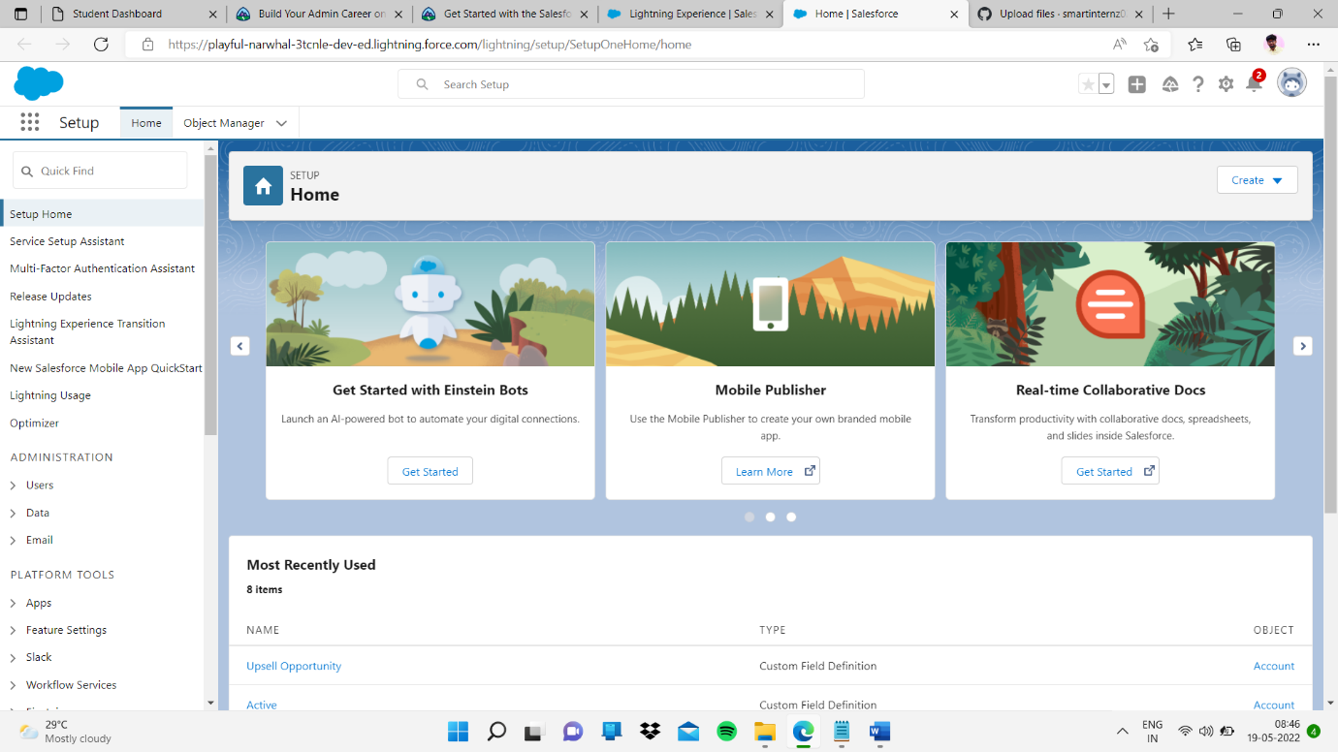

And I go throw object manager

And contacts

Filed:- currency next step

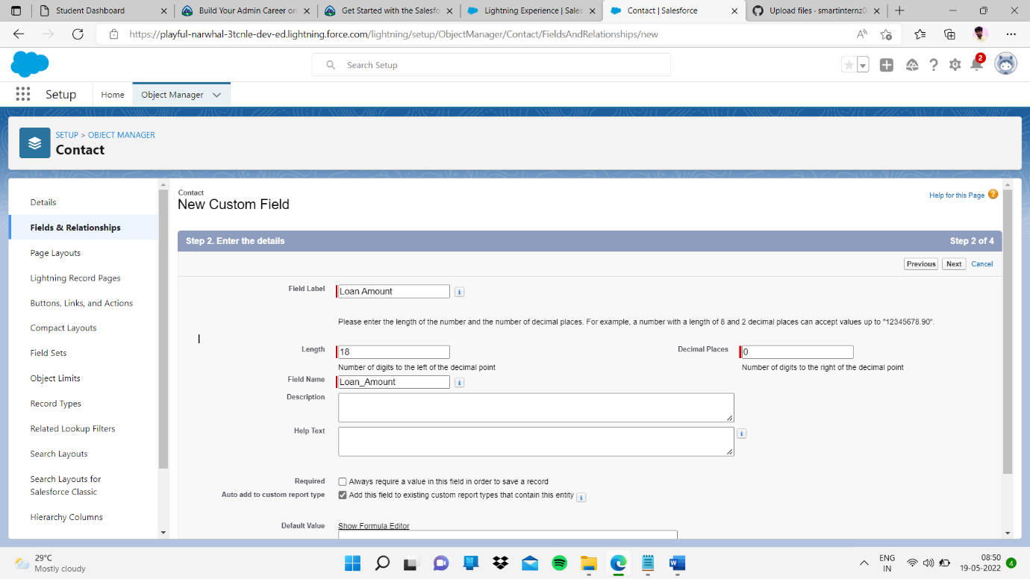

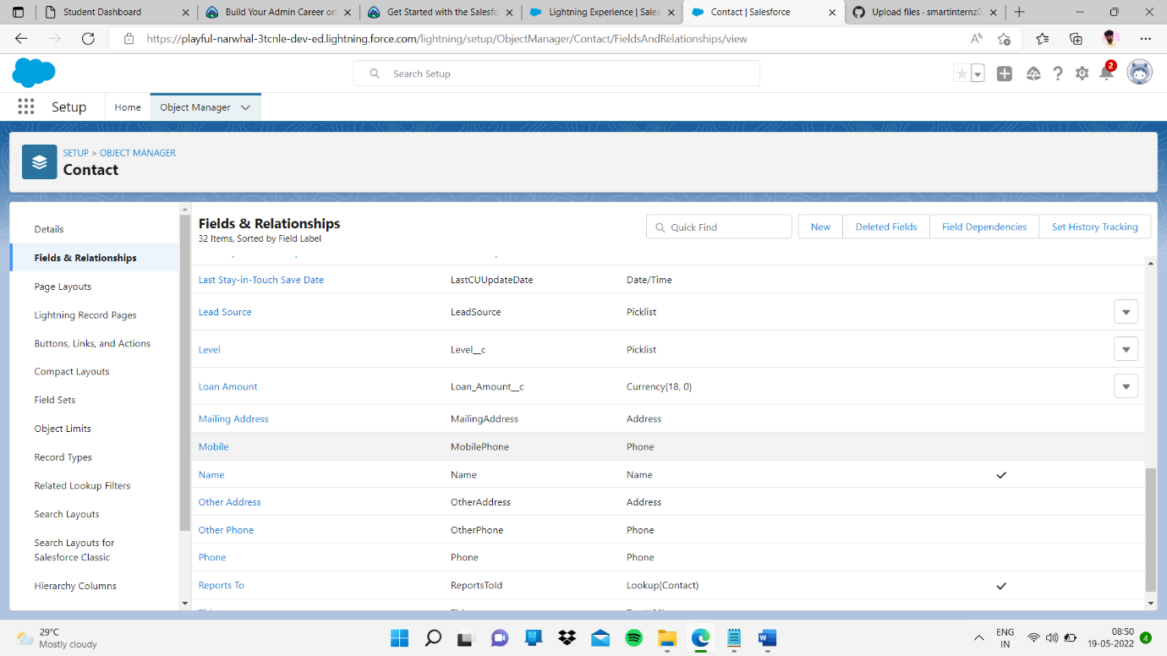

Finally I completed my task in Get Started with the Salesforce Platform I learn lot of thing how to use this setup